**Live vs. Dead Cells** are determined by cellular morphology - FSC and SSC - as well as DAPI or 7AAD staining. As cells die they shrivel and decrease in size (FSC is a measure of size). They also increase in granularity (SSC is a measure of granularity) as they undergo apoptosis. Therefore on a plot of FSC (x) vs SSC (y), dying cells will shift up and to the left. DAPI and 7AAD are both cell membrane integrity dyes that will only enter dead cells. Live cells will be DAPI-negative or 7AAD negative. These are cell membrane integrity dyes are interchangeable - DAPI and 7AAD are never used together in a single screen or staining panel.

**“Lineage” markers** positively identify mature cells of a known lineage. Leukemic blasts are normally negative for all of these markers (with rare exceptions). Notable often uses:  
CD3 (T cells)

CD19 (B cells)

CD66b (granulocytes)

CD235a (red blood cells)

**Blast markers** positively identify leukemic blasts. Notable uses the following 4 antibodies:

CD34

c-Kit (CD117)

CD33

CD45

CD34 and Kit (c-Kit, CD117 - all mean the same thing) are both markers of immature progenitor cells. They are so infrequent that they are undetectable in healthy peripheral blood, so any cells positive for these markers in a peripheral blood sample are definitively blasts. In healthy bone marrow, these markers are generally present ~1% or less so large populations of cells expressing either marker in bone marrow samples are also definitely blasts. Leukemias may have mixed expression with non-expression of these markers (ie only 25% of the blasts express CD34). Unfortunately, many leukemias lose expression of these markers in culture over 72 hours, so these blast markers are sometimes reduced or absent by the time of screen readout.

CD33 is very robust leukemic blast marker - expression of this marker does not appear to decrease in culture over time. However, healthy bone marrow or blood cells can express CD33 as it is a fairly common myeloid marker. Almost all myeloid leukemias are positive for either CD33 or CD34.

All white blood cells express CD45, but leukemia cells tend to express it at lower levels than some types of mature white cells, so they are referred to as CD45dim. Below is an example of the difference between a healthy sample and leukemic samples. Leukemic cells also tend to how low side scatter so this is often analyzed on a plot of CD45 vs SSC: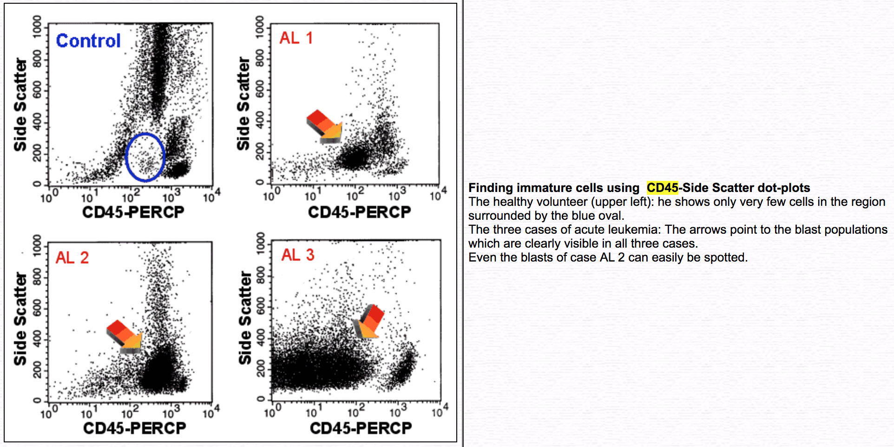

**Differentiation markers** are used by Notable to both identify healthy populations of mature myeloid cells (ie different types of monocytes and granulocytes) as well as to indicate differentiation of a leukemic blast. Notable’s commonly used Differentiation markers are:

CD11b

CD14

CD66b

CD163

CD38

CD11c